BLG439E
Computer Project I
Project I

We used speech-to-text functions for this project. User says their voice password and our program convert it to text and compare it with users saved voice password that in the database.

1) Encryption
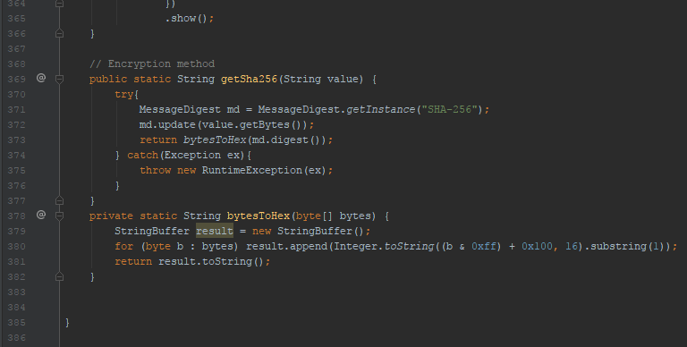
getSha256 function

We used sha256 method for encrypting the password and the voice password. This function is java.security.MessageDigest libraries function.

2) Database (Text file)
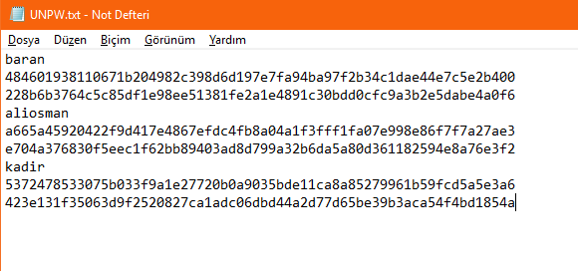
Inside the text file that used for database

Our databases inside is look like this text file. We store username than this user’s password and than same user’s voice password.

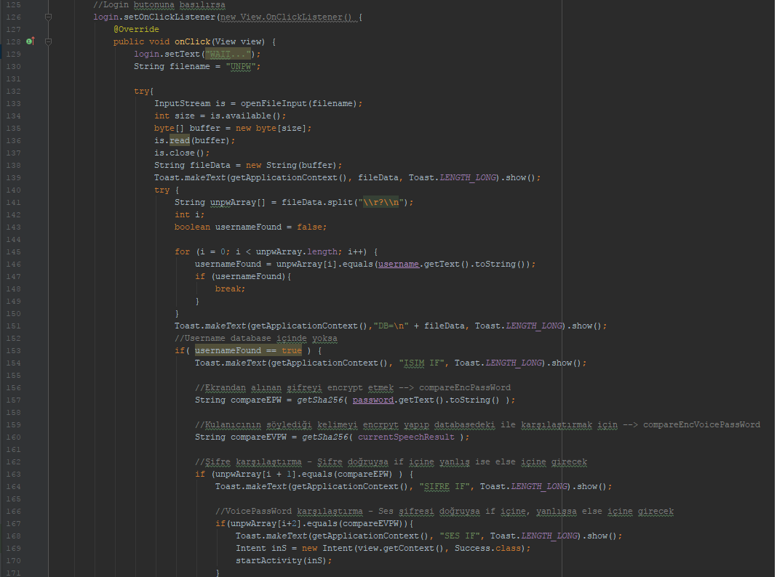
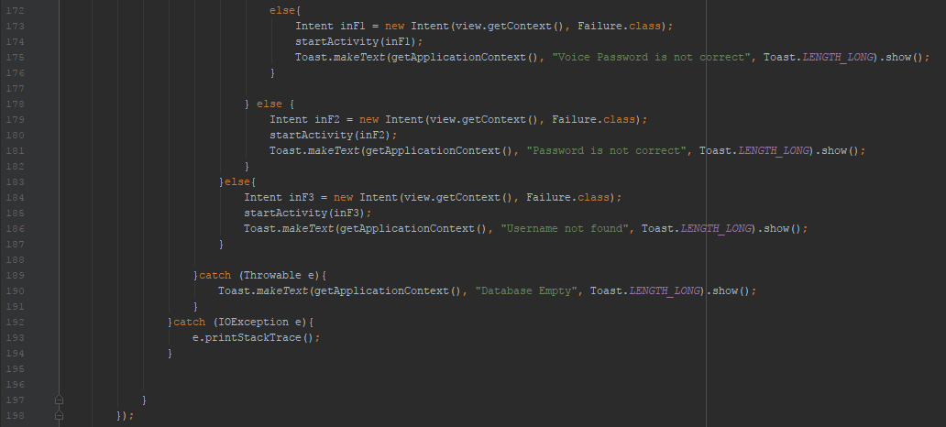
onClick Login button function

For comparasion to login event our code first searches for the written username in the text file. We used for loop for that purpose and if the loop cannot find the username in the file than the MainActivity event calls the Failure event and it opens the “Login Failed” screen. If for loop finds the username inside the file than it will compare encrpyted password with users encrpyted password. If passwords are not the same than Failure event will be called. However, if passwords are the same than program will compare the encrpyted voice passwords. If voice passwords could not pair than Failure event will be called but if all passwords are correct than the Success event will be called. And every failure shows their cause at the bottom of the Failure screen.
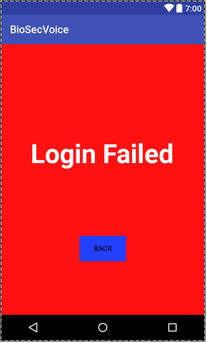
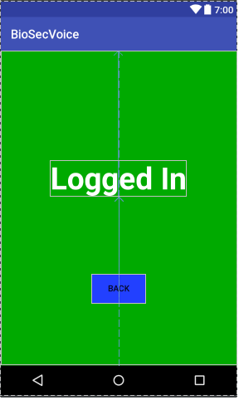
Failed&Success screens

If new user wants to enroll the database user must fill the username and password and also user must say his/her voice passport to the phone than user can pres the register button to enroll.

Our program uses openFileInput and openFileOutput methods to read/write files. First porgram reads the database file for already registered data and then it will add new users data (username, password and voice password) to at the end of the first files data. Program concatenate the two strings and then writes this new string to the file (When concatenating 2 strings, it will add newline symbol between 2 string and than concatenate them. It is because our database seperates different variables with newline symbol.). If program could not open the file while reading or writing it will throw exception.
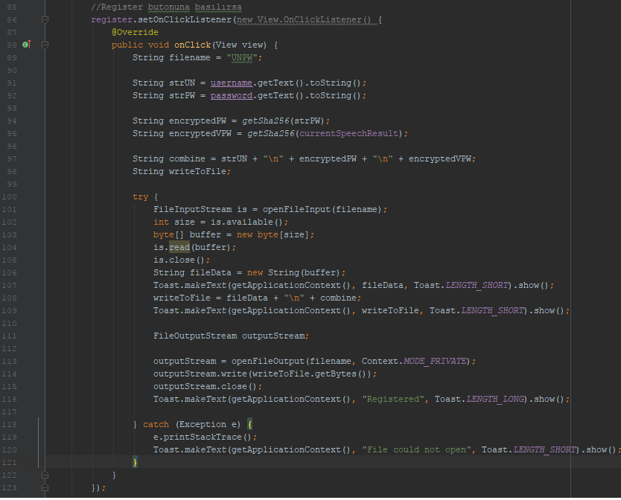
3) Voice to Text

We used Anroid speech master project for our projects biometric security part. This project uses Google Speech library and functions to recognize voice.

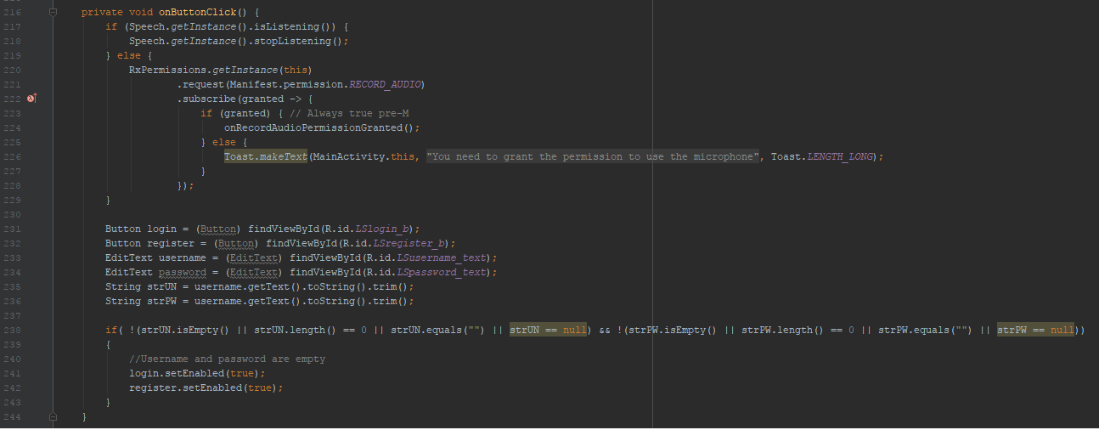
OnClick Mic Button funciton

When user clicks the microphone button it will call the Speech functions in our project. These Speech functions are Android speech master’s codes.
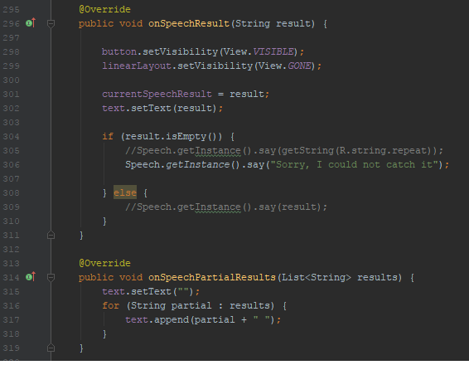
Result is the result of Speech functions and it is String

We used a global string variable to store Speech functions result. When user clicks the login or register button, program uses this global variable to compare the voice passwords or to add to new user to the database.

4) Other Codes
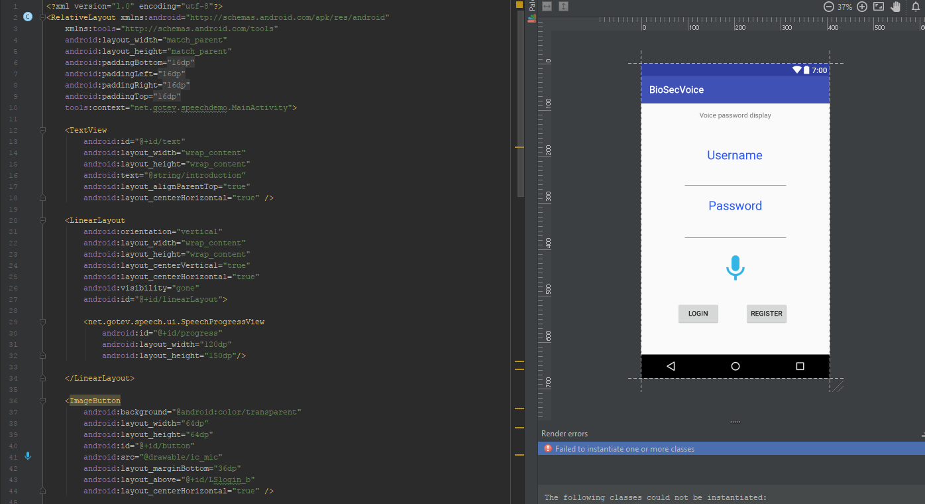
MainActivity screen (xml)

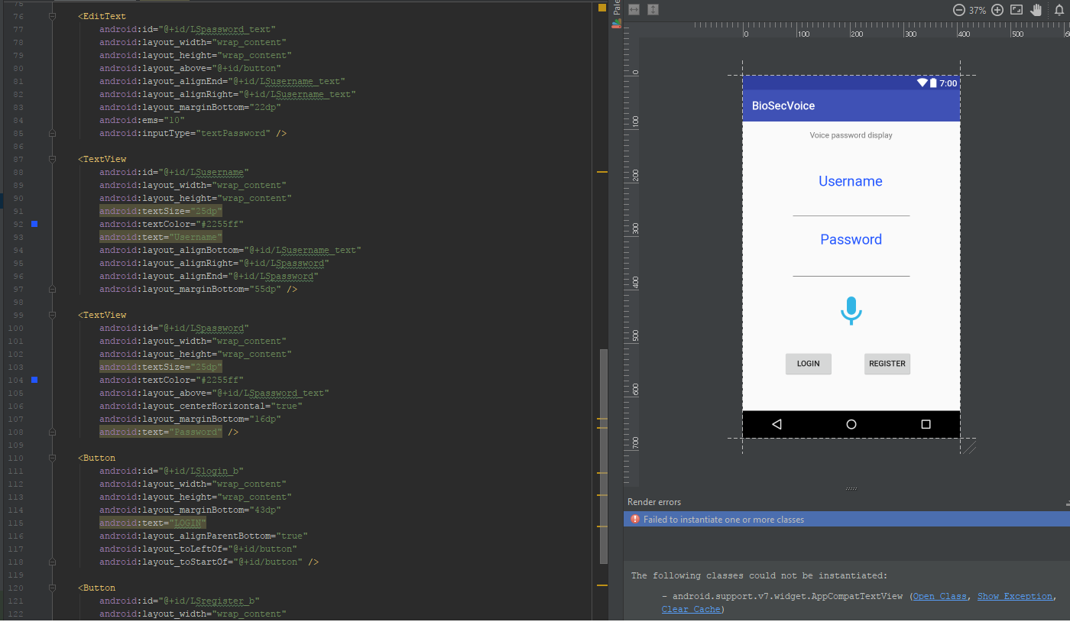
MainActivity screen (xml)

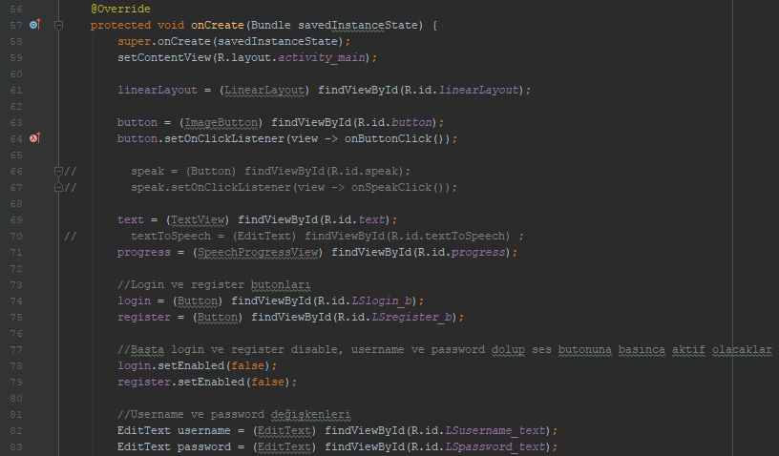
MainActivity classes (event) onCreate function

These codes for getting users input from EditText or Button variables.

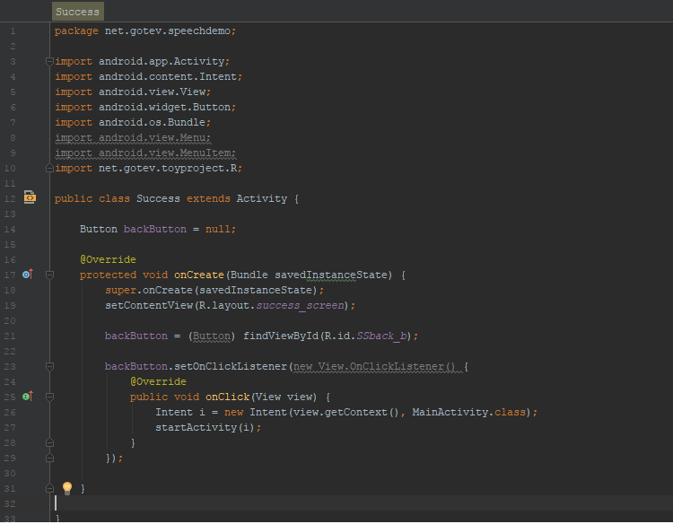
Success Event
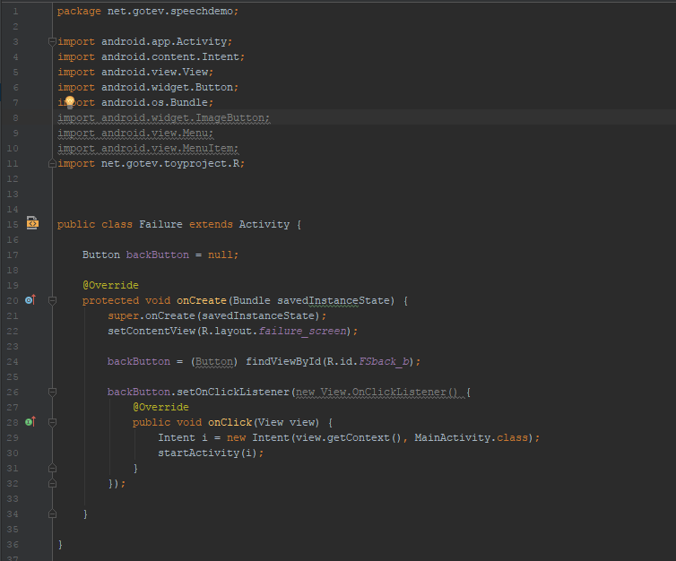
Failure Event

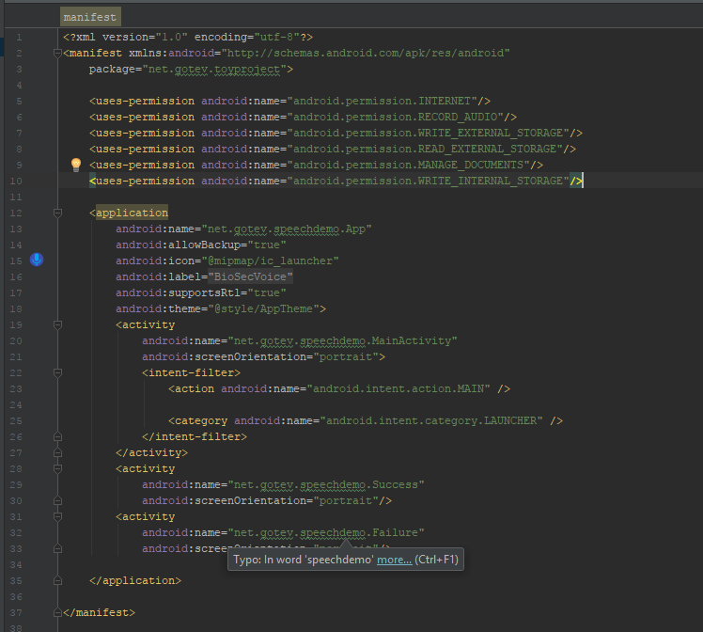
Manifests

